10 MST Task
Design a DVD Slick

Your task is to individually design a DVD slick or cover for a film
of your own invention.

Just like this one... for ‘Summer Rain’ (2001)

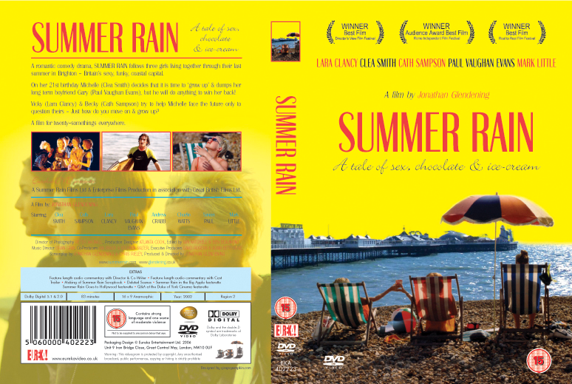

Step 1. RESEARCH & PLANNING

- First you must do some research. Look at a lot of other DVD slicks/covers at a video store, online or in class.

Using Pre-Production Chart A complete the following steps;

Step 2. GENRE
- Decide what genre your film is going to be; romantic comedy, drama, horror, musical etc...
Step 3. PLOT
- Then have a good long think about what your film is going to be about and write out the basic plot.

Step 4. DEFINE YOUR FILM
- Define your film by choosing; characters, a title, actors/stars, the setting & location, costumes, props etc…

Step 6. WRITE A ‘BLURB’ for the back of your slick
- Tell a possible audience; why they should watch it? who is in it? and what is basically going to happen? (Just don’t give it all away!)

Using Design & Layout Chart ‘B’ complete the following steps…

Step 5. DESIGN YOUR DVD SLICK
- Choose images for your cover and put your DVD slick together on the computer.
- Remember to ‘SAVE AS’ using your full name in ‘10MST Vidio Slick’ folder on student dump.

Step 7. TO FINISH…
You must hand in;
- A printed Black & White A4 copy of your DVD slick
- Completed charts A & B
- A full colour copy saved in ‘10MST Video Slick’ folder on student dump.

Assessment Criteria

Achievement | Merit | Excellence
- Complete a DVD slick using a limited range of conventions, from a design and plan. | - Complete a developed DVD slick using a limited range of conventions, from a design and plan. | - Complete a crafted DVD slick using a limited range of conventions, from a design and plan.

Achieve - Complete a media product using a limited range of conventions means to finish a product which:
- uses a limited range of given conventions of a genre
- shows some control of production technology
- broadly reflects the intention of the design and plan.

Merit - Complete a developed media product using a limited range of conventions means to finish a product, using well considered choices, which:
- uses a limited range of given conventions of a genre
- shows control of production technology
- reflects or adapts the details of the design and plan.

Excellence - Complete a crafted media product using a limited range of conventions means to finish a product, using well considered choices, which:
- uses a limited range of given conventions of a genre to create an effective whole
- shows consistent control of production technology
- reflects or adapts the details of the design and plan.
Pre-Production Chart ‘A’

TO DO LIST: Tell us about it... Tick!
Title of your film
Genre
Plot summary | Set up…  Crux of the story…  Resolution….
Characters | Characters continued…
Costumes, props
Setting – Time period & Location
Think about ‘genre’ | How will an audience know what kind of film this is without having to read the blurb?
The BLURB! | Why should an audience watch your film?  Who is in it and what character do they play?  What is basically going to happen?  (Just don’t give it all away!)

Design & Layout Chart ‘B’

TO DO LIST: Tell us about it… Tick!
Design the layout of your DVD slick | Where is the title going to go?  What’s on the front?  What’s on the back?  What images are you going to use?

